PE Funding

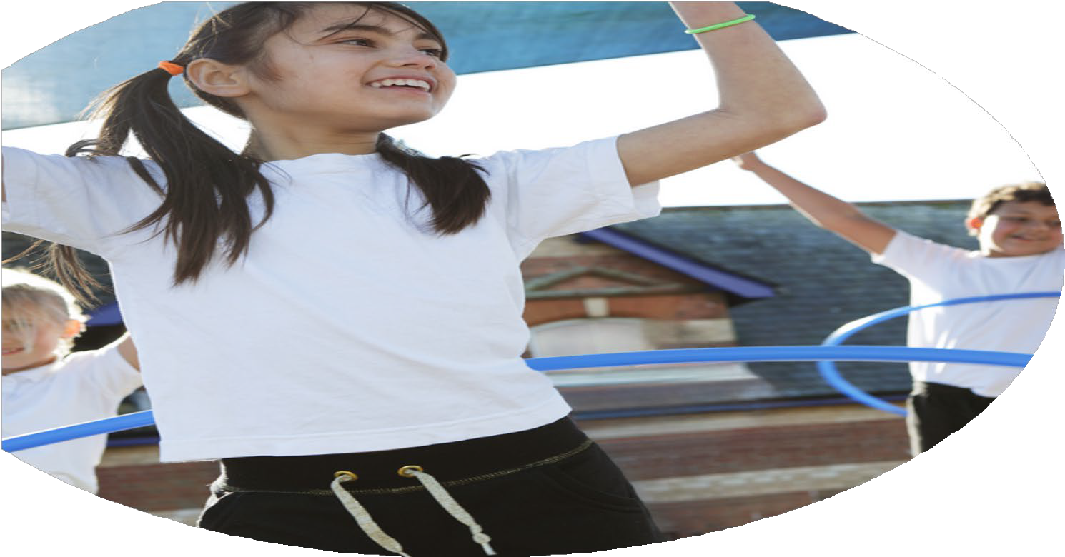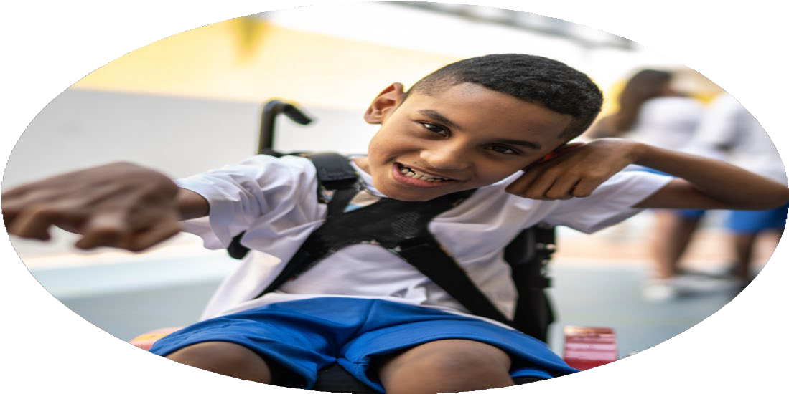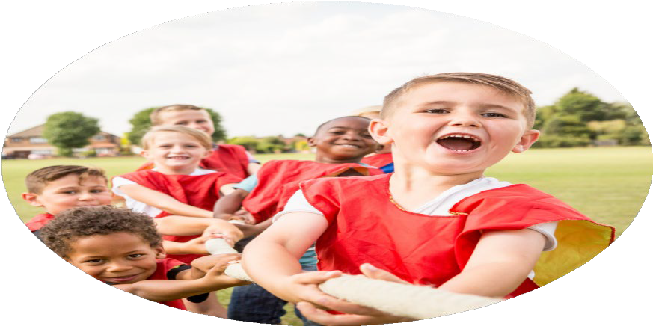

Evaluation Form

**Commissioned by**

**Created by**

Images courtesy of Youth Sport Trust

**PE Funding Evaluation Form**

 It is intended that this template should be used as preparation for the completion of the statutory digital reporting tool being introduced this academic year. You can upload data (including swimming) from this template onto this platform once it becomes accessible.

 Before you decide how you are going to use the funding for this academic year you should reflect and evaluate the impact of your use of the funding in 2023/24.

 All spending of the funding must conform with the terms outlined in the Conditions of Grant document.  The template is a working document that you can amend/update during the year.

 Based on your evaluation of last year’s funding you should decide what you intend to do this academic year, how you will do it, and what impact you expect it to have.

It is important that the funding is used effectively and based on your school’s needs.

 You must use the funding to make additional and sustainable improvements to the PE and sport in your school.  You must develop and add to the PESSPA activities that your school already offers.

*Summative digital reporting from June 2025 will continue to include swimming and water safety information therefore funding can be used to provide top-up lessons where necessary to ensure pupils meet national curriculum swimming requirements.*

**We recommend that you start by reflecting on the impact of current provision and reviewing your previous spend**

|  |  |  |  |
| --- | --- | --- | --- |
| What went well? | How do you know? | What didn’t go well? | How do you know? |
| Increased provision for all children – Both at dinner time and after school.  As a whole school and particularly identified key groups including:  Increased numbers of SEN and Disadvantaged pupils were able to participate in and access wider opportunities and provision.  More participation in SSG/TT events, increased opportunities for **all children**.  More children experiencing a wider variety of activities.  Increased success at competitive even  All staff have had CPD on delivering high quality PE and additional coaching sessions.  Monitoring and lessons observations have ensured PE provision is high quality.  The pop-up pool is proving successful. We are getting consistently good results.  The model of Y4 swimming for 2 weeks and the third week being for interventions of children in Y’s 5 and 6 who have been identified as children who would benefit from extra sessions/interventions is giving our children the best possible chance of hitting or getting as close to NC recommendations as possible. | We have even more clubs on offer this year. Including: KS1 Football, Y3/4 Football, Y5/6 Football, Girl’s Football, kS1 Indoor Games, KS2 Dodgeball, Arts and Crafts KS2, Sewing club KS1, Film club KS1/KS2, Running club Y 4-6, Tag Rugby club Y5/6, Gym club Y1-3, Forest Schools Y3-6, kS2 Indoor Games, Math’s Club Y3-6, Hockey Club Y3-6, Forest Schools club, American Football club, gym club, Yoga club.  We have also run dinner time clubs/sessions for Gifted and Talented children and for children who are competing for the school in both the Triumph Trust Cup and Sainsbury’s School Games events including – Rowing, Archery, Dodgeball, Football, Sports Hall Athletics.  Young Carers group have had additional swimming sessions.   * On average 346 children attending clubs each half term. * As a percentage this is 76% of all children on role Years 1-6. * 55% of children attending clubs are Disadvantaged pupils. * 28% of children attending clubs have SEN.   100% of children in KS2 participated in our TT Sports day at the Butts.  100% of children took part in EYFS/KS1 Sports days within school.  Resource base classes – Stay and play session, parents and children all participated in an afternoon of different physical and sporting activities.  Increased participation in SSG events.  Continuation of Triumph Trust Cup events/games and fixtures from Y1 – Y6.  Increase in inclusive sports events:   * Young carers to had additional swimming sessions and participation in “Paddlefest,” where they went kayaking. 22 children, all of our young carers were involved. * SEN specific events including boccia, archery, SSG activity day at Excel Centre. Resource base children and SEN children attended. * SSG events like dodgeball and Hado allowed different groups of children to participate in “Develop,” events which have less of a focus on competition. We were able to allow children lacking in confidence in PE or indeed disengaged from physical activity to participate and have some fun being active.   Our camping and residential trips have again been completely inclusive and we have used outdoor activities and experiences as a tool for whole school improvement. Children are more resilient, open to new experiences and prepared to give things a go.  Team successes included our gym team receiving gold medals and finishing first place in Coventry East, reaching the county finals.  Also, our Tag rugby team finished runners up in their pool and reached the city finals held at The Butts Park Arena.  When questioned all staff that had the training are:   * More confident using the Real PE Platform. * Teaching Real PE as their weekly PE lesson. * 73 % of the Year 6 cohort can swim competently, confidently and proficiently over a distance of at least 25 meters. * 81% 15m and over. * 81% of the Year 6 cohort can use a range of strokes effectively [for example, front crawl, backstroke, and breaststroke. * 100% of the Year 6 cohort can perform safe self-rescue in different water-based situations.This was our priority. Prior to the Y6 intervention sessions only 83% of the year group could perform self-rescue. We targeted the 17% who still couldn’t do this in our interventions. By the end of it they could all perform Self Rescue. | Are we doing enough for girls? Are we encouraging equality and participation of girls in sports?  Are we doing enough for children with a particular talent or skill in sport?  Could we have more success in competitive sports? Could we find pathways for talented children in Sports outside of the school environment.  Due to PPA cover our current model of PE provision means not all staff taught PE this year. Are some staff becoming deskilled?  Meeting NC recommended expectations/data for swimming. | Girls football team only had two fixtures, less than boys.  Although more children than ever have participated in a wider variety of sports, we are considering that there could be more opportunities for children with a particular talent or skill. Other than gymnastics, no club/training was offered to talented children. This club resulted in the gymnastics team winning gold in city event.  Could we enjoy more successes? Win the TT Shield this year? Progress further in more competitions?  Not all staff are confident delivering PE.  We still don’t quite meet NC end of Y6 expectations for swimming. |

|  |  |
| --- | --- |
| What are your plans for 2024/25? | How are you going to action and achieve these plans? |
| Intent | Implementation |
| Continue to prioritize swimming. Improve swimming data to meet NC expectation for all or majority of children.  The profile of PE and sport is raised across the school as a tool for the whole school improvement.  Increased participation and success in competitive sport. | Purchase of “Pop up pool,” Continue to run intervention/catch up sessions.  Sainsburys School Games subscription.  Continue to offer as many children as possible opportunities to participate in sporting events/competitions that are outside of the PE curriculum.  Including representing the school and opportunities to attend clubs, both at dinnertime and after school.  Continue to promote and develop “Active dinner times,” – Train DRA’s, use outside agencies to run clubs at dinner time.  Ensure all KS2 pupils benefit from taking part in a sporting event in a stadium – KS2 Sports Day.  Continue to work closely with Courthouse Green Primary school on all Trust Sporting events.  Work also with Rugby Free Primary School to develop further opportunities for children to participate in competitive sports across Triumph Learning Trust.  Run G n T clubs with Courthouse Green to raise standards and performance and give talented children the chance to thrive and shine. |

|  |  |
| --- | --- |
| What impact/intended impact/sustainability are you  expecting? | How will you know? What **evidence** do you have or  expect to have? |
| Pop up pool a success and enables us to continue to improve our swimming data.  Continued high participation in PE/Sports that are in addition to the curriculum. Including TLT Events, SSG events, CSA events, clubs and training sessions.  High quality training/coaching opportunities for G n T children.  More active dinner times with more confident staff delivering high quality opportunities and provision for all children to be active. More choice for children and target specific children to increase physical activity and enjoyment of sport. | Improved data from assessments in comparison with previous years, increase number meeting expected standard.  Data from Sainsbury’s School Games application and online Health check.  Gold Kitemark.  Improved attendance at clubs.  Increased events/competitions entered.  Increased success at events.  Specific clubs for specific targeted groups of children.  Observe and work alongside dinner staff to train them to confidently deliver active sessions.  Surveys and questionnaires for children and staff.  Data collection and registers. |

|  |  |
| --- | --- |
| What **impact/sustainability** have you seen? | What **evidence** do you have? |
|  |  |