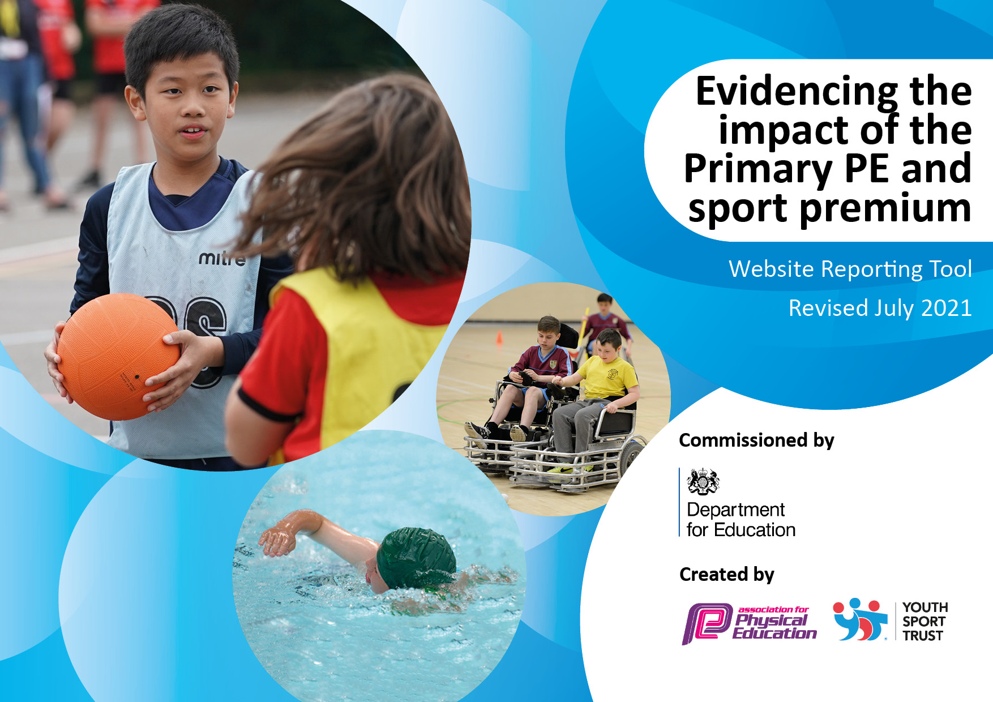

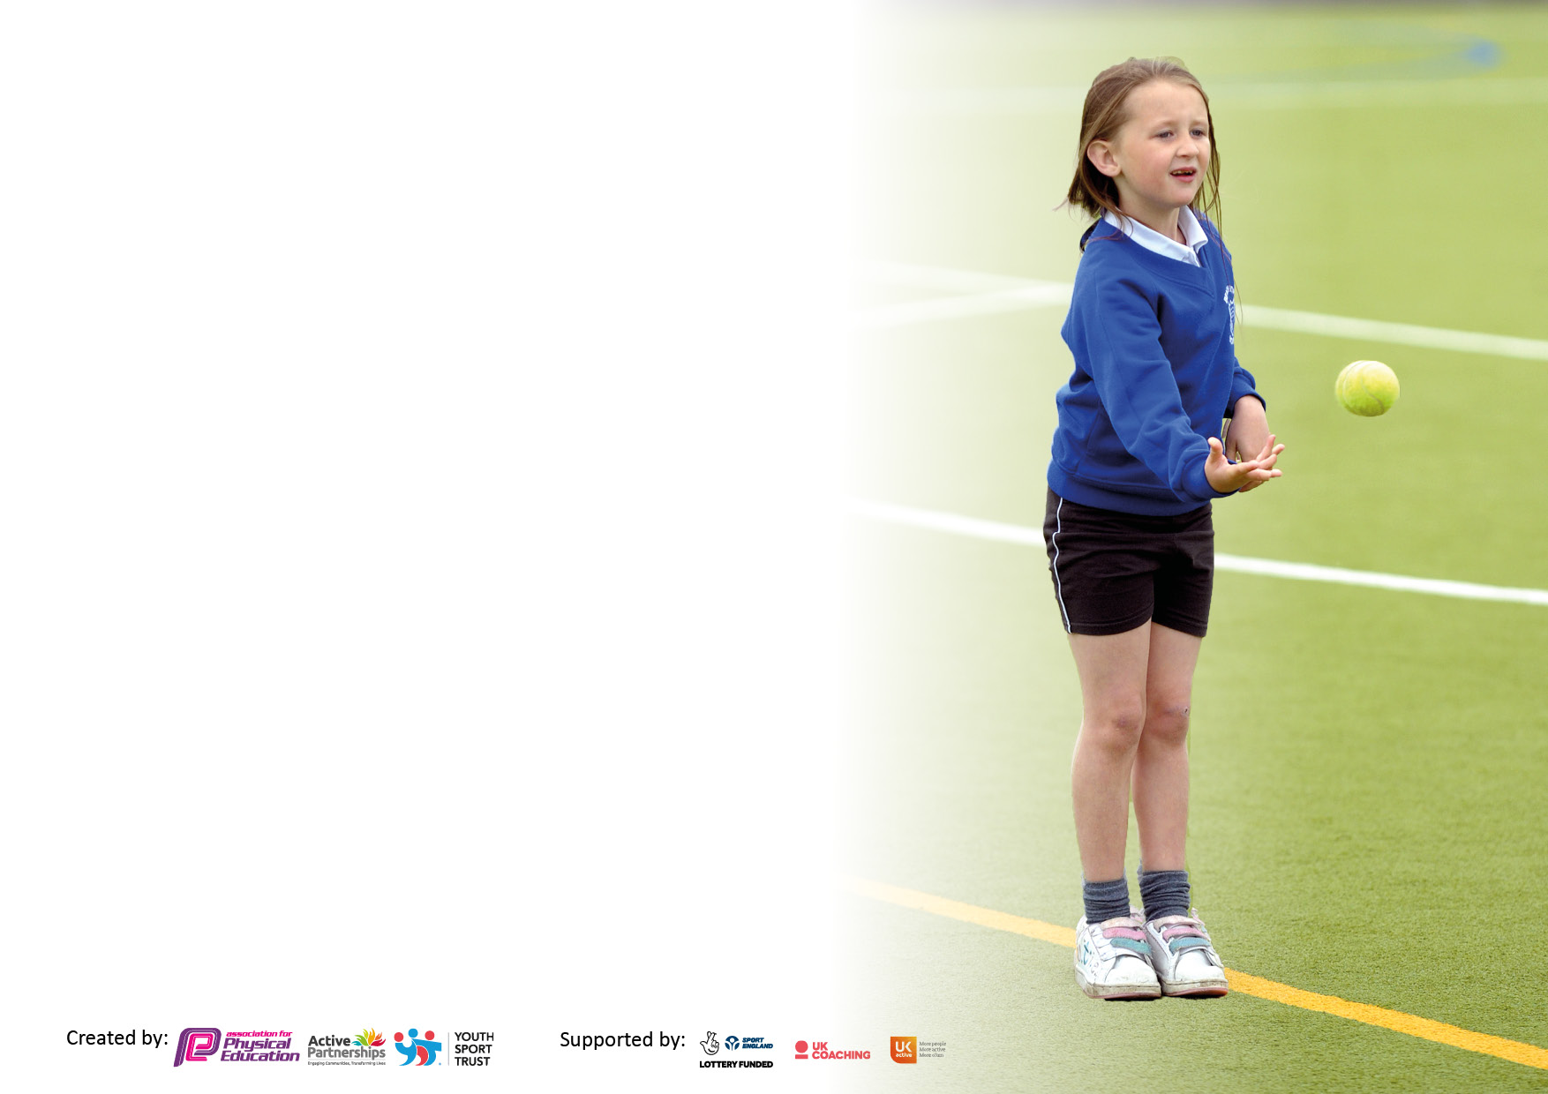

It is important that your grant is used effectively and based on school need. The [Education Inspection Framework](https://assets.publishing.service.gov.uk/government/uploads/system/uploads/attachment_data/file/843108/School_inspection_handbook_-_section_5.pdf) makes clear there will be a focus on **‘whether leaders and those responsible for governors all understand their respective roles and perform these in a way that enhances the effectiveness of the school’**.

Under the [Quality of Education](https://assets.publishing.service.gov.uk/government/uploads/system/uploads/attachment_data/file/843108/School_inspection_handbook_-_section_5.pdf) Ofsted inspectors consider:

**Intent** - Curriculum design, coverage and appropriateness

**Implementation** - Curriculum delivery, Teaching (pedagogy) and Assessment

**Impact** - Attainment and progress

To assist schools with common transferable language this template has been developed to utilise the same three headings which should make your plans easily transferable between working documents.

Schools must use the funding to make **additional and sustainable** improvements to the quality of Physical Education, School Sport and Physical Activity (PESSPA) they offer. This means that you should use the Primary PE and sport premium to:

* Develop or add to the PESSPA activities that your school already offer
* Build capacity and capability within the school to ensure that improvements made now will benefit pupils joining the school in future years
* The Primary PE and sport premium should not be used to fund capital spend projects; the school’s budget should fund these.

Pleasevisit[gov.uk](https://www.gov.uk/guidance/pe-and-sport-premium-for-primary-schools)fortherevisedDfEguidanceincludingthe5keyindicatorsacrosswhichschoolsshoulddemonstrate animprovement.Thisdocumentwillhelpyoutoreviewyourprovisionandtoreportyourspend.DfEencouragesschools to use this template as an effective way of meeting the reporting requirements of the Primary PE and sport premium.

We recommend you start by reflecting on the impact of current provision and reviewing the previous spend.

Schools are required to [publish details](https://www.gov.uk/guidance/what-maintained-schools-must-publish-online#pe-and-sport-premium-for-primary-schools) of how they spend this funding, including any under-spend from 2020/2021, as well as on the impact it has on pupils’ PE and sport participation and attainment. **All funding must be spent by 31st July 2023.**

We recommend regularly updating the table and publishing it on your website throughout the year. This evidences your ongoing self-evaluation of how you are using the funding to secure maximum, sustainable impact. Final copy must be posted on your website by the end of the academic year and no later than the 31st July 2021. To see an example of how to complete the table please click [HERE](http://www.afpe.org.uk/physical-education/wp-content/uploads/afPE-Example-Template-Indicator-2018-Final.pdf).



**Details with regard to funding**

Please complete the table below.

|  |  |
| --- | --- |
| Total amount carried over from 2021/2022 | £425.25 |
| How much (if any) do you intend to carry over from this total fund into 2023/24 | £270.62 not spent |
| Total amount allocated for 2022/23 | £20,740 |
| Total amount of funding for 2022/23. To be spent and reported on by 31st July 2023. | £21,005.25 £20,734.63 spent |

**Swimming Data**

Please report on your Swimming Data below.

|  |  |
| --- | --- |
| Meeting national curriculum requirements for swimming and water safety.  N.B. Complete this section to your best ability. For example you might have practised safe self-rescue techniques on dry land which you can then transfer to the pool when school swimming restarts.  **Due to exceptional circumstances priority should be given to ensuring that pupils can perform safe self rescue even if they do not fully meet the first two requirements of the NC programme of study** | Swimming ids a priority at Alderman’s Green.  For the past two years we have had a pop-up pool in school and children have had intensive daily lessons. We have also had a series of interventions and top up lessons to give our children the best chance of at the very least having water confidence and being able to perform self-rescue. We are also trying to increase the amount of Y6 leavers who also meet the first two NC requirements.  Please see Swimming Report June 2023 for a more detailed analysis of provision. |
| What percentage of your current Year 6 cohort swim competently, confidently, and proficiently over a distance of at least 25 metres?  What percentage of your current Year 6 cohort swim competently, confidently, and proficiently over a distance ofbetween 15 - 25 metres?  **N.B.** Even though your pupils may swim in another year please report on their attainment on leaving primary school at the end of the summer term 2023.  Please see note above | 62%  76% |
| What percentage of your current Year 6 cohort use a range of strokes effectively [for example, front crawl, backstroke and breaststroke]?  Please see note above | 76% |
| **What percentage of your current Year 6 cohort perform safe self-rescue in different water-based situations?** | 83.35% |
| Schools can choose to use the Primary PE and sport premium to provide additional provision for swimming but this must be for activity **over and above** the national curriculum requirements. Have you used it in this way? | Yes £ 700  Please see Swimming Report June 2023 for a more detailed analysis of provision. |

**Swimming Report June 2023 for Year 6 Leavers June 2023**

Total on roll June 2023 – 89

Intervention data from 2022 (when children were in Y5)

|  |  |  |  |
| --- | --- | --- | --- |
| Initial Assessment Data | | | |
|  | Self-Rescue | Water Confidence | 25m/range of strokes |
| Yes | 4 | 22 | 1 |
| No | 22 | 4 | 25 |
| Total | 26 | 26 | 26 |
| % Yes | 15.38% | 84.62% | 3.85% |
| % No | 84.62% | 15.38% | 96.15% |

|  |  |  |  |
| --- | --- | --- | --- |
| Final Assessment Data | | | |
|  | Self-Rescue | Water Confidence | 25m/range of strokes |
| Yes | 11 | 25 | 5 |
| No | 15 | 1 | 20 |
| Total | 26 | 26 | 25 |
| % Yes | 42.31% | 96.15% | 20% |
| % No | 57.69% | 3.85% | 80% |

Intervention data from 2023 (when children were in Y6)

|  |  |  |  |
| --- | --- | --- | --- |
| Initial Assessment Data | | | |
|  | Self-Rescue | Water Confidence | 25m/range of strokes |
| Yes | 8 | 14 | 0 |
| No | 9 | 3 | 17 |
| Total | 17 | 17 | 17 |
| % Yes | 47.06% | 82.35% | 0 |
| % No | 52.94% | 17.65% | 100% |

|  |  |  |  |
| --- | --- | --- | --- |
| Final Assessment Data | | | |
|  | Self-Rescue | Water Confidence | 25m/range of strokes |
| Yes | 14 | 17 | 2 |
| No | 3 | 0 | 15 |
| Total | 17 | 17 | 17 |
| % Yes | 83.35% | 100% | 11.76% |
| % No | 17.65% | 0% | 88.24% |

This cohort of children was affected by Coronavirus and didn’t swim when in Y3 or Y4.

They were given all given an initial assessment in June 2022 when in Y5. From those assessments we found that 71 % could comfortably perform self-rescue, had good water confidence, and could swim confidently between 15 – 25m.

We made the decision to then over the next 2 years target the other 29% of children who we deemed to need interventions and “Top up,” sessions to at the very least be confident in water, perform a range of strokes and hopefully start to be able to swim unaided.

On leaving school (2023)

* 76% could swim 15 - 25m/range of strokes.
* 100% had water confidence.
* 83.35% could perform self-rescue.

When this cohort were in Y5 (2022)

* 71% could swim 15 - 25m/range of strokes.
* 42.31 % had water confidence.
* 57.69% could perform self-rescue.

No data available for before 2021 due to Coronavirus.

Additional info – of the 26 children given interventions 17 were DP. 65%.

**Action Plan and Budget Tracking**

Capture your intended annual spend against the 5 key indicators. Clarify the success criteria and evidence of impact that you intend to measure to evaluate for pupils today and for the future.

|  |  |  |  |  |
| --- | --- | --- | --- | --- |
| **Academic Year:** 2022/2023 | **Total fund allocated: £21,005.25** | **Date Updated: July 2023** | |  |
| **Key indicator 1:** The engagement of all pupils in regular physical activity – Chief Medical Officers guidelines recommend that primary school pupils undertake at least 30 minutes of physical activity a day in school | | | | Percentage of total allocation: |
|  |
| **Intent** | **Implementation** | | **Impact** | £8601.13 |
| Your school focus should be clear what you want the pupils to know and be able to do and about  what they need to learn and to  consolidate through practice: | Make sure your actions to achieve are linked to your intentions: | Funding allocated: | Evidence of impact: what do pupils now know and what can they now do? What has changed?: | Sustainability and suggested next steps: |
| All children have access to two weekly PE lessons across the whole school. One of these lessons is taught by the class teacher where we use the Real PE Scheme.  Through these lessons children learn the physical skills outlined in the PE curriculum.  **Master basic movements including running, jumping, throwing and catching, as well as developing balance, agility and co-ordination, and begin to apply these in a range of activities.**  **Participate in team games, developing simple tactics for attacking and defending.**  **Perform dances using simple movement patterns.**  **Develop flexibility, strength, technique, control and balance.**  These skills are developed and built upon in a progressive way as children move through the school.  Jasmine | NewsThrough the REAL PE program, we have a focus on the mental and social skills of the children. Across the year, there is a **focus on 6 different cogs (multi abilities) which are not sports skill related.**  For PE and Sports to have a high profile across school and to encourage children to seek out and engage in Physical Activity outside of curriculum time. | * Continue to Use Real PE scheme. * All Class Teachers to deliver one Real PE lesson a week. * Purchase resources to support Real PE and equipment to support more after school clubs. * Purchase resources to improve provision and the range of activities on offer at break and dinner times. * More children more active at break/dinner times. * Greater variety of clubs on offer. * More children attending clubs. * Awards and celebrations of sporting achievements at different levels to raise the profile of PE/Sports. | £2290 Real PE subscription.  £545 Real PE whole school CPD.  £3230.13 (Various PE Schools Resource providers.)  £2536 (Various PE Schools Resource providers.) | * Using the monitoring facility on Jasmine (Real PE Platform,) GE observed that 95% of staff had used the platform to teach 5 or more lessons. * When questioned children understood why they were doing Real PE. * When questioned 79% of children said that they enjoyed Real PE. * Those that didn’t either said that they preferred their other PE lesson where they were leaning and playing “Proper games and sports,”   Or that they didn’t enjoy PE.   * Through following the REAL PE program, we can see children making progress with basic physical literacy in EYFS and KS1 and can see children’s skills develop and improve as they move into KS2. Children are competent in the skills outlined in the National Curriculum and through the use of the multi-ability cogs, we have observed children being more resilient and socially adept in different situations which arise both in PE lessons and in the classroom. * Autumn Term – 241 children attended clubs. * Spring Term – 251 children attended clubs. * Summer Term 263 children attended clubs. * 251 Average of pupils. * As a percentage this is 53 % of all children on role Y’s 1-6. * Last year we had 127 (32% of all children on role.) attending clubs per term on average. * 21% increase in attendance at clubs this year. * 51 % of those children were DP | * Continue to subscribe to Real PE and embed the whole school approach to teaching PE. * Continue a program of monitoring and support. * Book in more Real PE CPD * Make sure the assessment Tool is run out across the whole school to evidence impact. GE * Try to ensure children appreciate the importance of Real PE and continue to highlight why we do it. Make clear the links between Real PE, GE’s PE lessons (games etc) and T Trust/SSG events and competitions. * Continue to promote the importance of active lifestyles and the importance and benefits of being fit and healthy. * To show data which supports the positive impact Real PE is having by running out the assessment tool across the whole school. * Can we offer more clubs? * Can we increase participation of DP pupils in clubs? * Audit and order of resources. * Have a team of play leaders (Y6) to support and encourage active play at break and dinner times. * CPD for LSA’s to ensure we continue to offer a variety of well supervised activities at dinner time. |
| **Key indicator 2:** The profile of PESSPA being raised across the school as a tool for whole school improvement | | | | Percentage of total allocation: |
| % |
| **Intent** | **Implementation** | | **Impact** | £600 |
| Your school focus should be clear what you want the pupils to know and be able to do and about  what they need to learn and to  consolidate through practice: | Make sure your actions to achieve are linked to your intentions: | Funding allocated: | Evidence of impact: what do pupils now know and what can they now do? What has changed?: | Sustainability and suggested next steps: |
| For children in our school to see the benefits of exercise and PE, including things in addition to physical wellbeing. i.e. How being active can improve mental wellbeing.  To develop links with outside agencies and provide pathways for children in sports outside of the school environment. | * Sky Blues in the Community SBitC to deliver the joy of moving and reading stars programs. | £600 | * 79% of participants have improved physical well-being. * 64% of participants have improved mental well-being. * 45% of participants feel more inspired and engaged. * 67% have improved confidence and self-esteem. * 66% now participate more in physical activity. * 79% are seeking pathways into sport outside of school following our sessions. * These are the results of the pre/post KS2 questionnaires completed by pupils engaged in the SBitC Premier League programs including Reading Stars and Joy of moving. | * Continue to work with SBitC. * Book in provision for next year   . |

|  |  |  |  |  |
| --- | --- | --- | --- | --- |
| **Key indicator 3:** Increased confidence, knowledge and skills of all staff in teaching PE and sport | | | | Percentage of total allocation: |
| % |
| **Intent** | **Implementation** | | **Impact** |  |
| Your school focus should be clear | Make sure your actions to | Funding | Evidence of impact: what do | Sustainability and suggested |
| what you want the pupils to know | achieve are linked to your | allocated: | pupils now know and what | next steps: |
| and be able to do and about | intentions: |  | can they now do? What has |  |
| what they need to learn and to |  |  | changed?: |  |
| consolidate through practice: |  |  |  |  |
| For all teaching staff to feel confident in delivering PE lessons to their class.  For all staff to feel confident in using the REAL PE scheme of work, using the online learning platform to support lessons.  Staff to feel confident in using and making reference to the multi-ability cogs as part of their PE teaching.  Pupils should make good progress with PE and develop their skills and confidence as a result of a confident PE teacher. | * Continue to Use Real PE scheme. * To question staff on areas they would like support with and have CPD based on these findings. In order that Real PE is being used effectively and consistently as a whole school. * Demo day. * GE to monitor staffs use of Real PE as a manager on the Jasmine platform. * Observe lessons and offer support where needed. | Spend on Real PE and resources as detailed in Funding allocation for Key Indicator 1. | * Questionnaire was completed and staff requested support with navigating the Jasmine platform. All staff then received CPD on this. When questioned after 100% said they now felt more confident using the platform. * Staff also requested some “Demo lessons,” so they could see “Real PE,” in action. So, an afternoon of Demo lessons were put on. All staff got to see at least one lesson. Again, when questioned after 100% staff said that they found this beneficial and would help to improve the delivery of their Real PE lessons. * GE observed 3 different lessons being taught. All lessons were good. The children engaged and the staff confident using the platform and delivering Real PE. | * A continued program of monitoring, encouragement and support of staff. * More questionnaires and CPD booked in to support staff’s needs. |
| **Key indicator 4:** Broader experience of a range of sports and activities offered to all pupils | | | | Percentage of total allocation: |
|  |
| **Intent** | **Implementation** | | **Impact** | £6261 |
| Your school focus should be clear | Make sure your actions to | Funding | Evidence of impact: what do | Sustainability and suggested |
| what you want the pupils to know | achieve are linked to your | allocated: | pupils now know and what | next steps: |
| what they need to learn and to consolidate through practice? | intentions: |  | can they now do? What has changed? |  |
| For children to experience new activities and develop new skills.  Children provided with the opportunity to take part in exciting activities that are not part of the normal curriculum or school life.  For children to be able to develop and demonstrate some of the schools Core Values.  Including: Pride - Collaborate - Responsibility - Kindness – Resilience. | * Core Values Days – All children in KS2 to take part in two days of Physical activities. * Rock Wall * Archery * Shelter Building * Team games * Develop a Forest School at Alderman’s Green. * Start taking Forest School groups. * Purchase resources for Forest School. * GE to undertake Forest School training and become a Forest School Leader. | £4212  £900 Forest School training.  £1149 Resources to help set up and establish a Forest School. | * All children in attendance on the days in KS2 participated in all four activities. * Many examples of Core values being demonstrated, i.e children overcoming uncertainty and nerves and showing resilience by climbing up the rock wall, kindness, and collaboration during Team game sand shelter building.   Responsibility during archery etc.   * All children when asked were able to say how they had achieved at least one of the Core Values. * GE finished the course, Resources purchased, forest School set up. * Four initial sessions taught, feedback from children extremely positive – “Can we do this again next year!” * Children who participated (six Y5 boys,) all thoroughly engaged and demonstrating Core values, in particular collaboration when building dens. | * Book in again for next year, review the activities, which were the favourites? * GE to complete and submit coursework. * GE,GW and MC to work together to establish a Forest School Curriculum at Alderman’s Green. * GE to be observed. * Forest Schools lessons/sessions to start. |
|  |  |  |  |  |
|  |  |  |  |  |

|  |  |  |  |  |
| --- | --- | --- | --- | --- |
| **Key indicator 5:** Increased participation in competitive sport | | | | Percentage of total allocation: |
| % |
| **Intent** | **Implementation** | | **Impact** | £4572.50 |
| Your school focus should be clear | Make sure your actions to | Funding | Evidence of impact: what do | Sustainability and suggested |
| what you want the pupils to know | achieve are linked to your | allocated: | pupils now know and what | next steps: |
| and be able to do and about | intentions: |  | can they now do? What has |  |
| what they need to learn and to |  |  | changed?: |  |
| consolidate through practice: |  |  |  |  |
| All children to feel the pride of being part of a team and representing the school. Various levels of competition, activities and events in order to achieve this including:  Develop, participate, Compete.  All children in KS2 given the chance to compete in a professional arena in front of an audience.  Maximise participation of children in competitions of all levels. | * Continue and build upon the success of last year’s Triumph Trust Cup events and fixtures with Courthouse Green. * SSG Events. * Joint Trust sports Day. | £3000 purchase of minibus to allow access to an increased number of events.  £800 cost of transport for Triumph Trust Sports day.  £522.50 – Hire of Butts Park Arena and staffing for Triumph Trust Sports day.  £250 SSG annual contribution. | * Achieved the Gold Kite Mark for the second year in succession. * Participated in eight SSG events/competitions. * Held twelve Triumph Trust events and fixtures. * More children given the opportunity to participate in a TT Event. * Finalists in both Boys and Girls Tag Rugby SSG. * All children (100% of those in attendance on the day) took part in the Triumph Trust Sports day and took part in both field and track events. * 40% of children in Y’s 5 and 6 took part in a SSG event or competition (Level 3) * 29% of children in Y’s 3 and 4 took part in a SSG event or competition. * Took part in an SEN specific event for the first time – Archery. Five children from Parakeets/Ravens took part. | * Increase the number of events and the number of children participating in SSG events. * Provide opportunities to train for specific events to hopefully see more success. * Continue to look for opportunities for a wide section of pupils from school to be given the opportunity to compete, SEN. * Continue to work closely with Courthouse Green School in order to maximise children’s opportunities to compete and represent the school. |

|  |  |
| --- | --- |
| Signed off by | |
| Head Teacher: |  |
| Date: |  |
| Subject Leader: |  |
| Date: |  |
| Governor: |  |
| Date: |  |