
Alderman’s Green: Where everyone believes in us and we believe in ourselves.

Relational Behaviour Policy
At Alderman’s Green, we believe that each person in the school has the right to feel safe, valued, respected and happy. Everyone is expected to maintain the highest standards of personal conduct, to accept responsibility for their behaviour and encourage others to do the same. We believe that this will support our children to learn to manage their own behaviour and to be responsible for their own actions.
By forming positive, supportive relationships and by everyone acting as role models in school, we are promoting our Core Values of:
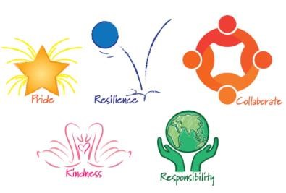
- Pride,
- Resilience,
- Kindness,
- Responsibility, • Collaboration.
These values are used consistently across the school and the language of our Core Values is used with all children and adults when referring to behaviour. Our values are taught and reinforced through assemblies, our curriculum and PSHE lessons; they help our children understand how to demonstrate these values in different places, in and out of school. Children are praised for demonstrating the core values.
At Alderman’s Green our approach to behaviour is a relational where we see behaviour as a communication of need. We use the current research in neuroscience and trauma informed approach which shows that positive relationships that promote high levels of care alongside high expectations are essential to children’s personal and academic success in school. Our relational approach follows three main steps:
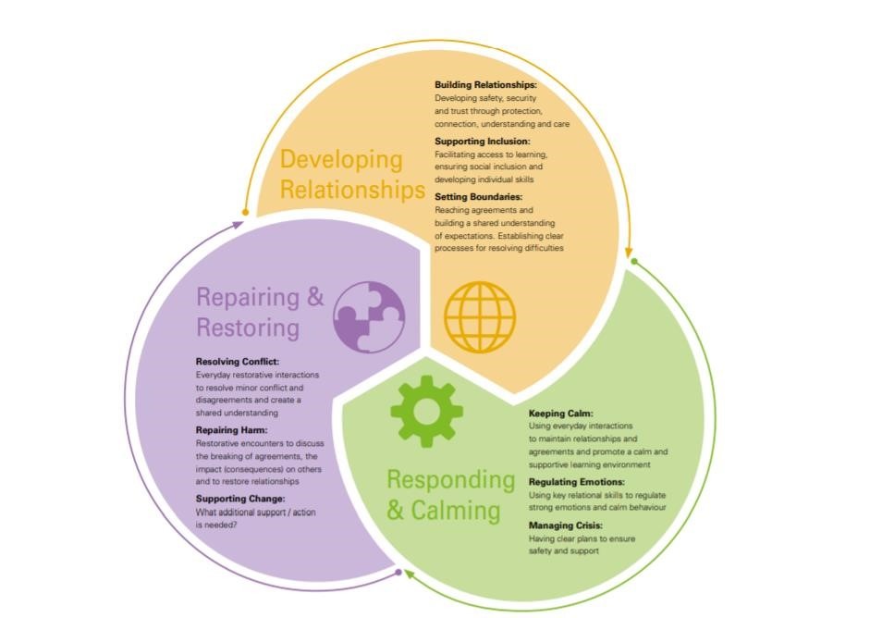

1. Developing Relationships
Our school ethos of kindness and by collaborating together as a ‘family’ underpins all that we do to ensure that school is a place of safety and a positive learning environment for all children. All adults in school invest in building relationships with the children they work with. All children are treated with kindness and valued as individuals. All members of staff in school are expected to model and promote positive behaviours embedding positive relationships. We all follow the principle’s from Paul Dix book (When the adult changes everything changes) of ‘visible consistency and visible kindness allow exceptional relationships and behaviours to flourish’ and that ‘praise in public, reprimand in private’ to support the culture of kindness.
Relationships are built through:
- Consistent caring adult behaviour,
- Clear high expectations for behaviour and learning, • Consistent routines and practice in all areas in school.

Setting boundaries and celebrating positive behaviour
Good and expected behaviour must be role modelled and promoted by all staff at all times. Around school children should be given regular, specific praise for excellent behaviour. To reward children’s positive behaviour, we use:
- Positive phone calls home,
- Positive post cards home,
- ‘Class Dojo’ where children can earn individual Dojo points
- Core Value Champions for to a child who has shown excellence in demonstrating the core values. A child or adult will explain why that child has been chosen and the child will receive a certificate to take home. • Core Value Tokens where children must collaborate as a class to earn tokens for demonstrating a Core Value. Each token is worth 5 minutes; these can be banked for longer periods of time (no more than 2 hours),
- Core Value Token’s will also be given out for attendance.
The reward system is designed to celebrate and encourage the individual skills and traits that are needed for children to develop a positive attitude towards their learning and development but also to support them to become responsible members of the school community by collaborating as a class.

Consistent routines
Through teaching and promoting the core values, children at Alderman’s Green learn that to achieve well and succeed in school they must work hard, concentrate and persevere when faced with difficult challenges. To do this the climate and ethos in the classroom needs to promote good behaviour for learning. To ensure this is able to happen, every day, in every lesson, teachers always ensure that the classroom is calm, well organised, resources for lessons are prepared and all classes have established routines that maximise learning time.
To develop the effective use of routines relationships across the whole school we have adopted key routines:
- Meet and greet all children positively when they arrive in the morning,
- Hand held up for children to stop,
- Turn and talk to your partner signal • Classes always line up in register order.
- Adults lead when classes are walking through school, moving around school in a line quietly and calmly so not to disturb learning.
- All children sit and eat together in the dining room and do not leave until it is time for all to leave.
Please see appendix 4 for further routines and social norms adopted.

Setting high expectations
In all areas in school children are reminded to demonstrate the Core Values by:
- responding when greeted in class or around school • Wearing the correct uniform with pride at all times.
- Work with pride in the classroom, ensuring work is always the best they can do and responding to feedback to improve.
- Maximising time to learn by following routines and starting work promptly.
- Being ready to discuss with talk partner and contribute,
- Show kindness with our words and actions, showing good manners and respect to all other children and adults
- Walk with responsibility in the corridors,
- Play with kindness on the playground,
- Collaborate to look after the school environment, ensuring it is well looked
- Show resilience to solve problems and make things right.
- To be honest and take responsibility for own actions.
- Ask for help when needed and use strategies taught to regulate behaviour.
It is the responsibility of all adults in school to model, remind and support children with these expectations.

Supporting Inclusion
We recognise that some children have difficulties in self-regulation and managing their own behaviour resulting in disruption to learning or relationships. Our expectation for all children are that they will follow our school based routines with support so that their behaviour does not impact on the learning of others. After teacher intervention, if children are regularly displaying unacceptable behaviours that impact on the calm learning environment for all they will be referred to the school’s pastoral team, SENCo and there will be support from their link member of the Senior Leadership Team. Support provided will be personalised to the child’s needs and may include:
- Thrive action plan
- Movement breaks
- Direct work
- Forest school provision
- External referral to specialist support or alternative provision

2. Responding and Calming
The Core Values are used by all adults to support children to make the right behaviour choices, the language of the values should be used to help the child reflect on and choose their behaviour.
All areas in school have Thrive calming areas for children to use to aid self-regulation, children are taught to use these resources and to understand how this is helping them be ready to learn again. Through Thrive sessions children are taught breathing techniques, mindfulness and calming strategies.
All adults in school will always respond to in a calm and consistent way. In the classroom adults use positive framing and language in line with the “30 second script” to support children in making positive behaviour choices (appendix 1). This sets a high expectation for behaviour along with a positive affirmation that the child can achieve this. Children will always be given time to correct the behaviour after the instruction is delivered. All children are entitled to a calm and safe place to learn and if a child’s behaviour is continually disrupting others they will be asked to leave the classroom.
Every classroom should be a positive learning environment and children should feel safe in all parts of the school. If a child continues to not follow instructions to keep themselves or others safe then parents will be contacted to discuss actions moving forward that are appropriate to the child’s circumstances.

Supporting children to regulate emotions
Children with many social, emotional and mental health difficulties will find self-regulating their emotions a challenge; we understand that their behaviours are a way of communication.
'We wouldn't punish children for reflex action, like a leg kicking if the knee is tapped. Nor should we punish pupils for behaving as if their world is not safe; because it may feel unsafe, for them, and that is not a physiological state anyone can be argued out of.' (Bombér 2020)
Children need to feel confident that an adult will support them to do this so that they feel safe (emotionally and physically) and that they will be supported to make choices to put their behaviour right. An adult will have to lend their “thinking brain” by talking out loud with the child using the Emotion Coaching Script (appendix 2). Only when the child has been supported to calm themselves must the consequences of the behaviour be discussed. Adults should make a clear distinction between validating the emotion whilst still highlighting the unacceptable behaviour and alternative positive choices for actions. Adults will respond in a predictable, prompt, kind and assertive manner, we will provide additional support where needed so that all children can meet our expectations.

Individual children
We recognise that some children in some circumstances, may find it difficult to regulate their emotions even with the support of an adult. In these situations, their behaviours may be dangerous to themselves and/or others. In these cases, children will need to have a Supporting Behaviour Plan (appendix 3) which identifies triggers, strategies and adults who can support the child. In all classrooms to promote a positive, calm climate we will use visual timetables and clear behaviour expectations.
In the case of an emergency situation, the adult supporting the child must request additional help from any available adult by requesting ‘help needed’. This can be done via telephone or person to the office, another member of staff in the year group, SLT, or Thrive practitioner.
3. Repairing and Restoring

Reflection
All unacceptable behaviours must be dealt with and addressed with the child. A playtime/lunchtime incident should be dealt with during playtime/lunchtime rather than interrupting learning time. Adults will ensure that children understand that an incident will be resolved at a given time during reflection time
(playtime/lunchtime/end of a lesson) to ensure the child is able to engage in their learning until this time. Adults will use these restorative interactions to help the child resolve the incident or conflict and understand how to repair the harm caused. The level of the behaviour may mean that there needs to be a further reflection time on other days to resolve and repair the incident.
Reflection time aims to:
- Teach children the impact of the behaviours they have shown,
- Support children to take responsibility for their own behaviour,
- Know how to repair the impact of their behaviour,
- Have positive strategies to improve their future behaviour.
Reflection Questions- these are the 5 focus questions for reflection. Tell me…
- What happened?
- What were you thinking and feeling- before, during and after?
- How do you think it has made the other person/ people feel and think?
- What could you do differently in the future?
- What should we do to put this right?

Adults reflecting on behaviour
It is essential that all adults in school reflect on the behaviour of the children they are working with and try to identify any underlying causes of areas of poor behaviour. We believe that behaviour is a communication of need or circumstances so adults need to understand how a change to provision or practice for the group or individual could help improve behaviour.

Sanctions
Behaviours not in line with our Core Values
Behaviour that can be effectively managed within a classroom environment by the class teacher. From following the structure of the 30 second script children may have lost a few minutes of playtime or lunchtime to complete any learning or to have a short restorative conversation with an adult.
Where the behaviour escalates so that it is not so easily managed in the classroom environment, there may be a need for another teacher from the year group to be involved or the link member of SLT. The child will receive a reflection (part/whole of lunchtime or all playtime); the class teacher, link SLT member or SLT member on duty can carry out this reflection time. Parents will be informed of the reflection by the class teacher. If persistent behaviour is disrupting the learning of others it may be decided that the child works out of their classroom for a
fixed period of time.
All behaviour incidents and reflections which lead to a loss of playtime/lunchtime must be recorded on CPOMS by the class teacher. This can be done by ticking the correct tab on CPOMs and then just adding a brief summary of the incident and time lost.
High Levels of Behaviour
Serious negative and/or unacceptable behaviour where the child has deliberately chosen to hurt another person (physically or verbally including racist/bullying/homophobic language) or damage to school or others property will involve head/ deputy head teacher or senior leader overseeing the year group.
The child will have a meeting with the head/ deputy head teacher/senior leader to discuss what has happened. After investigation, parents will be informed of the school’s actions and will be expected to support the school’s decision. An appointment will be made for parents, teacher, child and head/ deputy head teacher/senior leader to discuss the child’s future behaviour. All criminal behaviour will be reported to the police.
Consequences may include:
- Additional reflection sessions,
- Loss of extra- curricular activities/ any privileges,
- An Individual Behaviour Plan,
- A removal from class where a child will work in school but not in their own classroom,
- Suspension for a fixed period of time (1 to 5 days).
All behaviour incidents and reflections must be recorded on CPOMS.
Behaviours not in line with our Core Values | • • •  • | Not on task, wasting time, distracting others,  Deliberate avoidance, not completing work,  Calling out, attention seeking behaviour,  Accidental damage to school or others property through carelessness,
 | • | Running indoors.
 | • | Telling lies,
 | • | Teasing others – using unkind words/comments, name calling,
 | • | Persistent play fighting/rough play,
 | • | Answering back,
 | • | Retaliation.
High Levels of  Behaviour | • •  • | Stealing,  Continued refusal of adult’s reasonable request,  Inappropriate/ bad language. Any homophobic or racist language,
 | • | Deliberate graffiti or damage to school or another child’s property,
 | • | Deliberately hurting another child,
 | • | Serious acts of sustained violence towards children or adults eg. Kicking, fighting, hitting,
 | • | Dangerous behaviour due to not responding to an adult’s request,
 | • | Bringing dangerous items into school (vapes, knives, weapons, alcohol, drugs, stolen items, tobacco and cigarette papers, fireworks, pornographic images, any article that could cause injury, offense or damage)
 | • | Racial or prejudice abuse,
 | • | Bullying including cyber bullying.

Child on child abuse:
Where children’s behaviour falls below our expectations, whether on or off site or online that is either witnessed by staff or is reported to the school, we will collaborate with parents to resolve them, putting in place sanctions as appropriate. Negative interactions online can damage the school’s culture and can lead to school feeling like an unsafe place. Following any report of child-on-child sexual violence or sexual harassment offline or online, we will follow our Child Protection Policy and the information within Keeping children safe in education addressing it through appropriate sanctions. All staff will challenge inappropriate language and behaviour between pupils. Mobile phones are not to be used when on the school premises and should be handed to a member of staff on arrival.

Removal from class:
To support children who are presenting challenging behaviours in the classroom children may be temporarily moved to work in a separate area of school. The aim is to ensure they understand the acceptable behaviours that are needed to learn successfully in school. They will be supported by Thrive Practitioners or their link Senior Leader, who will help them practise strategies to ensure successful reintegration into their mainstream class.
Short term reduced timetables:
In exceptional circumstances, there may be a need for a temporary, fixed term, part time timetable to meet a pupil’s individual needs. Parents will attend a meeting with a senior leader to discuss the reduced timetable and will be given a signed copy of the plan at the end of the meeting. Children will be provided with sufficient and appropriate work that they need to complete during the hours that they are not in school. Information regarding all pupils on a reduced timetable will be shared with Governors and the Local Authority.
The action plan will:
- Specify an end date that the child is expected to return to full time education,
- Will be reviewed weekly,
- Be signed by parents to register their consent and that they are taking responsibility for the pupil when they are not in school and will guarantee that they will supervised when they off site,
- Be shared and understood by parents with clearly recorded objectives.
Suspension:
If a child has a fixed term exclusion as a result of their behaviour, work will be provided while the child is at home and parent and child must attend a reintegration meeting.
Reintegration following a fixed term suspension:
If a child has been suspended from school they will attend a reintegration meeting on their first day back with the Head/ Deputy Head teacher and parents. This meeting will be to reflect on the behaviour that led to the exclusion, allow the child to understand how to repair the impact of their behaviour and promote a climate of success and expectation for when they return to class. Strategies for reintegration include:
- A fixed period transition plan building up a child’s time back in school,
- A planned period of time in another area in school
- Improving behaviour chart,
- Actions for parents to put in place at home,
- Adult support in direct work and/or in the classroom.

In extreme cases the child may be permanently excluded, this sanction is used with the greatest reluctance. Fixed term suspensions and permanent exclusions will follow guidelines set by DFE. If children have persistent unacceptable behaviour an individual improving behaviour plan will be put into place. This will outline support given by class teacher, Thrive practitioners, external agencies and will set targets for improved behaviour and the consequence of continued unacceptable behaviour.

Safe Touch and Handling
Safe touch is used to calm, soothe and regulate a child’s emotions and is a needed developmental experience. The brain does not develop pathways to initiate calming and self-soothing unless and until this safe emotional regulation has been experienced within a positive relationship with a significant adult. Where children have had insufficient experience of safe touch and calming regulation, this may be a priority to help their brains to develop.

Safe Touch may be used in the following ways:
- To calm and comfort a distressed or upset child,
- To help regulate emotions when a child is feeling angry or frustrated,
- To reassure and calm an anxious or worried child,
- To support a child with low self esteem
- A Thrive intervention targeted to support social and emotional development

Some strategies that may be deployed are:
- Holding hand, hug or reassuring touch if a child is upset or distressed,
- Use of hand massage, modelling deep breathing or a rub on the back for an anxious or angry child, • Providing sensory input such as deep pressure hug/massage, support with sensory movements e.g.
crab walking/pushing/pulling activities/yoga.

If children are behaving in unacceptable, threatening, dangerous, aggressive or out of control way, they have not yet learned how their strongest emotional reactions can be contained, channelled and communicated safely. This may cause some children to exhibit some behaviours that may be dangerous to themselves, others, school property or that they may be at risk of suspension. On these occasions, staff may have to physically intervene in order to keep the child or children at risk, safe using Positive Handling. Members of staff have the power to use positive handling in school but will do so in a reasonable and proportionate way. In such circumstances we will always inform parents and may then put in place a Positive Handling Plan for a particular child.

4. Monitoring of Behaviour Incidents
Logged behaviour incidents will be viewed daily and monitored on a weekly basis by the member of Senior
Leadership Team linked to each year group. This will allow any persistent issues/ children to be identified. If a
child is persistently making poor behaviour choices this may indicate a safeguarding issue or signal an unmet learning or developmental need, these children will be referred to the school inclusion and pastoral team. Termly feedback will be sought from all children about the existing climate within school and a termly report on incidents and exclusions will be shared with Governors and the Trust Board.

5. Lunchtime behaviour
Lunchtime supervisors will follow the same behaviour policy as teaching staff. They will always role model good behaviour, be positive and praise children for good behaviour choices. Lunchtime supervisors will award Class Dojo points. When these are given to children, they will clearly explaining why they are giving to the child referencing the values.

Unacceptable behaviour at lunchtime
Lunchtime supervisors will use the 30 second script to support children to make good behaviour choices at lunchtimes.
If the behaviour continues after time out or if it is felt it is not safe for the child to stay on the playground the child may be taken to reflection. The should be clearly explained to the child. If a child will not cooperate or their behaviour is dangerous then a Thrive practitioner or senior leader will be called to support.

Reporting to Teachers
Lunchtime supervisors are expected to deal with behaviour issues that occur at lunchtime but any rough, aggressive or unkind behaviour must be fed back to the teacher or learning support assistant at the end of lunchtime. All lunchtime behaviour incidents will be logged on cpoms by the lead lunchtime supervisor.

6. Allegations

Malicious Allegations against staff
Any allegation against staff will be fully investigated by the Headteacher and if the allegation is found to be malicious consequences will be put in place that may include any of the above level 4 consequences and may lead to exclusion.

Physical contact with pupils
On rare occasions, it may be necessary to use reasonable force to prevent pupils from hurting themselves or others, from damaging property, or from causing disorder. This may be to control a situation by standing between children who are going to fight or leading a child by the arm to remove them from a situation.
Restraint may need to be used to prevent a pupil from attacking a member of staff or another pupil, or to restrain a pupil at risk of harming themselves through physical outbursts. Physical intervention should be avoided where possible and other strategies should always be used if possible. It is essential to never use any more force than is necessary and to try to ensure there is no physical injury to the child or staff member. Where staff act in good faith, and their actions are reasonable and proportionate, they will be supported.
The decision on whether or not to physically intervene is down to the professional judgement of the staff member concerned and should always depend on the individual circumstances. Any incident involving physical intervention is a high level incident and full details of what happened and the intervention used should be logged in the bound and numbered book, on CPOMs and reported to Head/ Deputy Head teacher.
When a child needs to be handled on a regular basis, a Positive Handling Plan will be created with parents to safe guard child and staff wellbeing. Adults in school have had Team Teach de-escalation and restraint training.

7. Induction of staff
Leaders will ensure that all new staff are fully inducted into school, so that they fully understand our school culture, values and routines and know how best to support all pupils to participate in learning, ensuring that they create a calm, supportive climate within the area of school that they work. All induction will be fully aligned to our relational behaviour policy, the Early Career Framework (ECF) together with the National Professional Qualifications in Leading Behaviour and Culture (NPQLBC).

8. Role of leaders
School leaders will act as role models at all times; demonstrating a consistent, predictable approach to children. They are highly visible throughout the school day, with leaders routinely engaging with children, parents and staff on setting and maintaining the behaviour culture and the environment where everyone feels safe and supported.

Links to other policies and documents
- Personal Development Strategy
- Exclusion policy
- Attendance policy
- Equality policy
- Safe Touch and Handling policy
- Search and Confiscation Policy

Policy approved: September 2024
Policy to be reviewed: September 2026

30 Second Script for managing classroom behaviour.

Step 1
I’ve noticed that you…
You are not showing our core value of… If you continue to do this you will be choosing to loose 5 minutes playtime.
Do you remember the fantastic… you did and how great you felt when you focused and worked hard?
That is who I need to see today. Thank you for listening.

Step 2
I’ve noticed that you are continuing to…
You are not showing our core value of… You have chosen to miss 5 minutes playtime. If you continue to do this you will be choosing to…
Do you remember that you are amazing at… when you focus and try your best?
That is who I need to see today. Thank you for listening.

Step 3
I’ve noticed that you are continuing to……
You are not showing our core value of …. You have chosen…
Do you remember the fantastic …… you did yesterday and how great you felt when you focused and worked hard?
That is who I need to see today. Thank you for listening.

30 Second Script for managing whole school behaviour.
Stop, Notice and Move on
‘I’m on my way to get my class. You know the rule about walking with pride in the corridor and I am sure you will do this. Thank you for listening’.
‘I need to work with ______. You know the rule about working with pride and I expect to see you doing that when I come back. Thank you for listening’.

Emotion Coaching Script

Step 1: Internally recognise the child’s feelings and empathise with them.
Also consider:
Are you the right person to speak to this child? Are you emotionally ready to speak to this child? Do you need help from another adult?

Step 2: Label and validate the feelings:
Label
You seem… to me
I can see that you are feeling…
I can tell that you are…
The way you are feeling is making you feel…

Validate
I am sorry that this has happened to you… you must feel…
I would feel… if that happened to me too.
It’s ok to feel…
I understand why you feel…
If the child is struggling to calm down at this point keep repeating the above whilst completing some soothing activities e.g. singing, colouring, scribbling, jumping, running, mindfulness, carrying heavy objects.
Step 3: Only when the child has calmed down… Set Limits and problem solve:
Set Limits
It’s not ok to behave like that…
In school, one of our rules that we have to follow is…
Doing that, is not ok…
Behaving like that is not helpful/safe/acceptable…

Problem Solve
What made you feel like that?
Have you ever felt that way before?
Let’s think of what you could of done instead…
I can help you think of a different way to cope…
Try and do this next time you feel like this…
Let’s decide what you can do next time you feel like this...

Supporting Behaviour Plan


Supporting Behaviour Plan
Name: Class:
Background:

School input:

Teacher input:

Behaviour | Response

Social Norms

Our agreed ‘social norms’ to support behaviour to be exceptional are:
Routines:
- Meet and greet all children positively when they arrive in the morning,
- Hand held up for children to stop,
- Turn and talk to your partner signal,
- Classes always line up in register order,
- Adults lead when classes are walking through school, moving around school in a line quietly and calmly so not to disturb learning,
- All children walk around school quietly and calmly, with and without an adult,
- Walk into the hall for assembly in silence. Children to remain standing to check that they have space to sit down before sitting down.

In class and corridors:
- Visual timetables are displayed and used daily to support with understanding the school day,
- Morning routine is consistent for all; welcome, put belongings away in drawers and on pegs, hand in reading book & bookmark, sit down in silence to complete ‘do it now task’ on the board/desk/iPad,
- Children work to agreed and set noise levels in class: silence, quiet voices, or normal voices. No outside voices to be used within the classroom,
- Children to tidy up after themselves and to keep school tidy e.g., pick up paper towels off the flood, hang up coats if they fall off pegs, keep the classroom tidy.

Uniform and equipment:
- Only school equipment to be used during learning time. Equipment from home to be stored in drawers/bags and only used for special occasions.
- Children bring their reading books and diary/bookmark into school daily – expectation to read 5 times per week,
- Children always wear the correct school uniform and PE kit,
- Only healthy snacks permitted,
- Water bottles are either kept on or near desks or on lunch trollies. Children understand that they do not drink from their bottle when an adult is talking,

Dining Room:
- Children to sit at the tables first and wait to be called to collect lunches,
- All children sit and eat together in the dining room and do not leave until it is time for all to leave,
- Children to always remain seated e.g., put rubbish in the bin at the end of lunch,
- No moving around or talking with mouths full,
- Putting hand up to gain adults attention,

- If another year group needs to be spoken to, staff supporting other year groups to use hand signal for all other children to be silent.

To ensure that behaviour is exceptional, and children are successful, ALL adults in school will:

- Invest time in building secure relationships with all children in their class,
- Greet children warmly, ask how they are and take time to talk and listen to children,
- Be present when working with children,
- Teach children expectations and social norms,
- Model behaviour expectations and social norms at all times,
- Model waiting and sitting in assembly in silence,
- Sincerely thank children and provide a reason/explanation of the desired behaviours/social norms,
- Be calm, consistent and predictable,
- Use Class Dojo to award points,

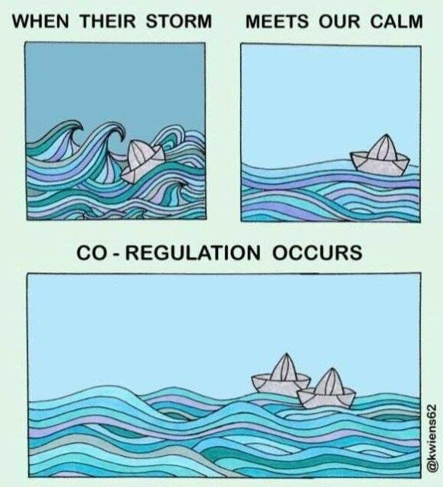
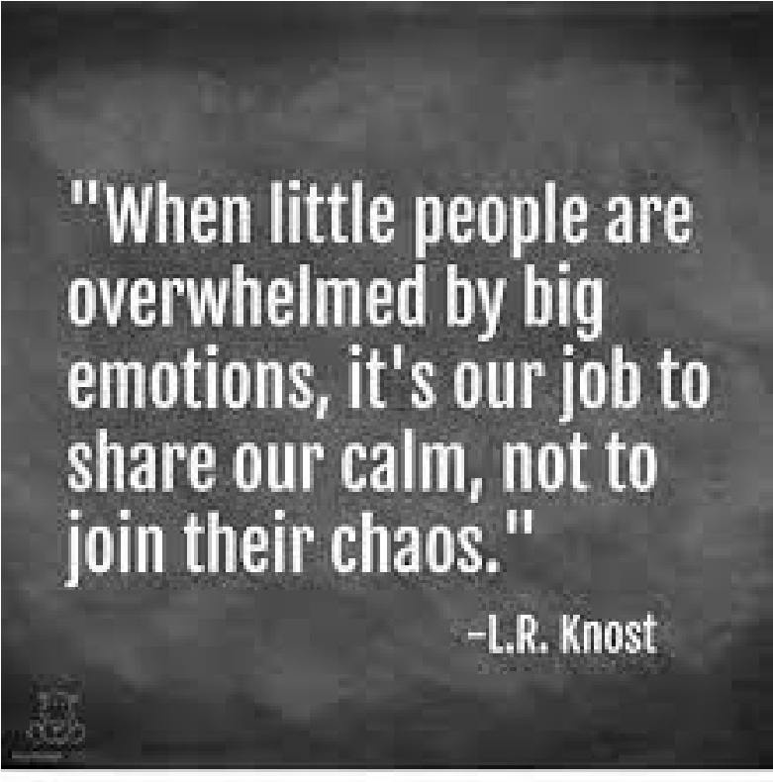


- Regularly share positive news with parents,

- Spotlight and celebrate exceptional behaviours,
- Use positive language,
- Promote exceptional behaviour for all children in school, not just those in a specific class/year group,
- Be confident to challenge behaviours,
- Have high expectations and aspirations for children; do not negatively label children or limit them due to any additional needs or vulnerability,
- Be warm demanders; do not use shouting, shame, or embarrassment as behaviour management strategies,
- Be aware of their self and when there needs to be a change of face to keep dignity for all,
- Provide children with the strategies and resources needed to be successful,
- Help children problem solve, resolve conflict, reflect, and repair situations,
- Understand where children’s behaviour comes from; do not give up on our children, even when times are difficult.
- Believe in all children and that they can achieve the most exceptional things!
- All staff should feel confident to sensitively hold each other account.

