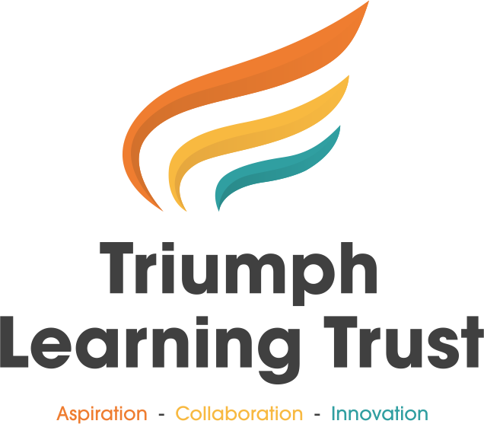

Relationships, Sex and Health Education (RSHE) Policy

Policy Details
Policy Level | Trust
Document Approver | Trust Board
Document Status | Draft
Applicable to | All Trust Employees
Review Frequency | Every Year

Revision History
Revision | Date | Details | Approved by
0 | September 2025 | First Issue

Contents
1. Introduction 3
2. Statutory Requirements 4
3. Aims 4
Our RSHE curriculum aims to: 4
4. Curriculum Content 5
5. Delivery 5
6. Parental Rights of Withdrawal 5
7. Equality and Inclusion 5
8. Monitoring and Review 5
9. Appendices 6
Appendix 1 – The guidance should be read in conjunction with: 7

Introduction
This policy sets out our school’s approach to Relationships Education, Relationships and Sex Education (RSE), and Health Education. We are committed to providing a curriculum that promotes the spiritual, moral, cultural, mental and physical development of pupils and prepares them for the opportunities, responsibilities and experiences of adult life.
RSHE is a statutory requirement for all schools under the Children and Social Work Act 2017 and the Relationships Education, RSE and Health Education (England) Regulations 2019.

This policy is designed to ensure pupils:
- Embrace the challenges of creating a happy and successful adult life, pupils need knowledge that will enable them to make informed decisions about their wellbeing, health and relationships and to build their self-efficacy
- Put this knowledge into practice as they develop the capacity to make sound decisions when facing risks, challenges and complex contexts. Everyone faces difficult situations in their lives. These subjects can support young people to develop resilience, to know how and when to ask for help, and to know where to access support.
- Prepare for the opportunities, responsibilities and experiences of adult life.

This policy is designed to ensure school and school leaders:
- Reflect the Relationships Education, Relationships and Sex Education and Health Education (England) Regulations 2019, made under sections 34 and 35 of the Children and Social Work Act 2017, make Relationships Education compulsory for all pupils receiving primary education and Relationships and Sex Education (RSE) compulsory for all pupils receiving secondary education.
- Outline both the rights of parents/carers to withdraw pupils from sex education (but not Relationships or Health Education) and the process that school leaders should follow in considering a request from a parent.
- Ensure parents have the right to request that their child be withdrawn from some or all of sex education delivered as part of statutory RSE.
- Are flexible in how to deliver the content, in the context of a broad and balanced curriculum.
- Enable staff to deliver effective teaching and learning in these subjects to ensure that core knowledge is broken down into units of manageable size and communicated clearly to pupils, in a carefully sequenced way, within a planned programme or lessons.
- Ensure teaching includes sufficient well-chosen opportunities and contexts for pupils to embed new knowledge so that it can be used confidently in real life situations.
- Support the lead teacher in working closely with colleagues in related curriculum areas to ensure Relationships Education, RSE and Health Education programmes complement, and do not duplicate, content covered in national curriculum subjects such as citizenship, science, computing and PE.
- Ensure systems check prior knowledge and that this is built this into the planning process to ensure a smooth transition between primary and secondary.
- Support all staff in being aware that for many young people the distinction between the online world and other aspects of life is less marked than for some adults.
NB Young people often operate very freely in the online world and by secondary school age some are likely to be spending a substantial amount of time online. Where topics and issues outlined in this guidance are likely to be encountered by pupils online, schools should take this into account when planning how to support them in distinguishing between different types of online content and making well-founded decisions and to support children in understanding, for example, social media users are sometimes prepared to say things in more extreme, unkind or exaggerated ways than they might in face to face situations, and some users present highly exaggerated or idealised profiles of themselves online.
- Provide clarity that some platforms attract large numbers of users with similar, sometimes extreme, views,
who do not welcome dissent or debate.
NB Young people should be aware that certain websites may share personal data about their users, and information collected on their internet use, for commercial purposes (i.e. to enable targeted advertising). In addition, criminals can operate online scams, for example using fake websites or emails to extort money or valuable personal information. This information can be used to the detriment of the person or wider society. Schools should take these factors into account when planning teaching of these subjects and consider the overlap with their wider curriculum to ensure pupils know how to keep themselves and their personal information safe.

Statutory Requirements
- Relationships Education is compulsory in all primary schools.
- Relationships and Sex Education (RSE) is compulsory in all secondary schools.
- Health Education is compulsory in all state-funded schools.
- This policy has been developed in line with the Relationships Education, RSE and Health Education Statutory Guidance (DfE, 2025).

Aims

Our RSHE curriculum aims to:
- Give pupils the knowledge they need to make informed decisions about health, relationships and wellbeing.
- Support pupils to develop resilience, self-esteem and confidence.
- Prepare pupils for the physical and emotional changes of growing up.
- Promote equality and respect for diversity.
- Equip pupils with strategies to stay safe, including online.

Curriculum Content
- Primary: Relationships Education focuses on families, friendships, respect, personal privacy, online relationships, and staying safe. Health Education includes mental wellbeing, internet safety, physical health, healthy eating, drugs and alcohol, and basic first aid. Puberty is taught as part of the science curriculum, with additional age-appropriate content provided.
- Secondary: RSE builds on this, covering healthy relationships, consent, contraception, sexual health, online safety, and the law. Health Education continues with more depth on mental health, lifestyle choices, and wider wellbeing.
- A detailed scheme of work is available to parents on request.

Delivery
- RSHE is taught by trained teachers, within the PSHE and science curriculum.
- Lessons are delivered in an age-appropriate, inclusive and sensitive manner.
- Resources used are quality-assured and accessible to all pupils, including those with SEND.
- External agencies may support delivery, but teaching is always led by a school staff member.

Parental Rights of Withdrawal
Parents have the right to request their child's withdrawal from the non-statutory components of Relationships and Sex Education (RSE), but not from the relationships, health, or mandatory science components of sex education.

Limited Withdrawal:
Parents cannot withdraw their child from Relationships Education, Health Education, or the science-based content of sex education.

Scope of Withdrawal:
The right to withdraw is specifically for the non-statutory, non-science components of sex education.

Age Limit:
The right to request withdrawal exists until three terms before the child's 16th birthday. After this point, a 16-year-old can make their own decision to receive the education if they wish to opt back in, overriding parental withdrawal.

Procedure for Withdrawal:
- Written Request: Parents must put their request in writing to the headteacher.
- Parental Discussion: The headteacher is expected to discuss the request with the parents to understand the reasons for it.
- Alternative Provision: The school must provide alternative work for the pupil during the RSE lessons from which they are withdrawn.
Parents do not have the right to withdraw their child from Relationships or Health Education.

Equality and Inclusion
- Teaching respects pupils’ religious backgrounds and the Equality Act 2010.
- All protected characteristics (sex, race, religion, disability, sexual orientation, gender reassignment, etc.) are respected and reflected in teaching.
- All pupils, including those with SEND, will access the full curriculum.

Monitoring and Review
- The delivery of RSHE will be monitored by the PSHE lead and senior leadership team.
- Pupil voice will be used to evaluate effectiveness.
- Policy will be reviewed, in consultation with parents, staff, and governors.

Appendices
Appendix 1 | Guidance to read in Conjunction with this Policy

Appendix 1 – The guidance should be read in conjunction with:

- Keeping Children Safe in Education (statutory guidance)
- Respectful School Communities: Self Review and Signposting Tool (a tool to support a whole school approach that promotes respect and discipline)
- Behaviour and Discipline in Schools (advice for schools, including advice for appropriate behaviour between pupils)
- Equality Act 2010 and schools
- SEND code of practice: 0 to 25 years (statutory guidance)
- Alternative Provision (statutory guidance)
- Mental Health and Behaviour in Schools (advice for schools)
- Preventing and Tackling Bullying (advice for schools, including advice on cyberbullying)
- Sexual violence and sexual harassment between children in schools (advice for schools)
- The Equality and Human Rights Commission Advice and Guidance (provides advice on avoiding discrimination in a variety of educational contexts)
- Promoting Fundamental British Values as part of SMSC in schools (guidance for maintained schools on promoting basic important British values as part of pupils’ spiritual, moral, social and cultural (SMSC)
- SMSC requirements for independent schools (guidance for independent schools on how they should support pupils' spiritual, moral, social and cultural development).
- National Citizen Service guidance for schools

